**BALDIVIS SECONDARY COLLEGE**

** Methods Units 1 and 2**

**2019 Test 1**

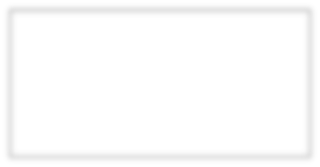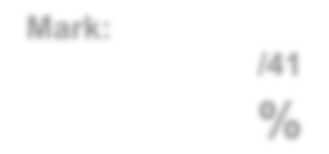

**Mark:**

**/46**

**%**

Student Name _____________________________________________

**Time allowed for this task:** 50 minutes, in-class, test conditions.

Section 1: 20 minutes + 2 minutes reading time

Section 2: 30 minutes + 3 minutes reading time

**Materials required:** **Section 1** Calculator free section (18 marks)

Standard writing equipment

SCSA Formula Sheet

**Section2** Calculator assumed section (28 marks)

Calculator (to be supplied by the student)

SCSA formula Sheet

One page A4 (double sided) hand written notes

**Other materials allowed:** Drawing templates

**Marks available:** **48 marks**

**Task Weighting: 5%**

**Question 1. [4 marks – 1, 1, 1, 1]**

Use the diagram of a 20o angle on a unit circle provided to **estimate** the following values to two decimal places;

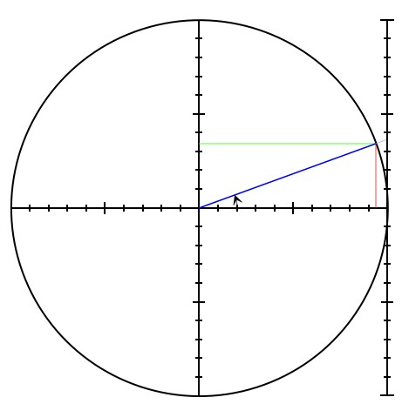

1. cos 20o

1. sin 20o

1. sin 160o

1. tan 160o

**Question 2** **[3 marks]**

The angle of inclination of a linear graph is 30o. Calculate the gradient of this line. Give your answer as an exact value. *Hint: Draw a sketch.*

**Question 3** **[4 marks-2, 2]**

Express the following in terms of angles between 0° and 90° and then state their exact value:

(a) tan150° (b) sin135°

Angle between 0 and 90o: Angle between 0 and 90o:

Exact value: Exact value:

**Question 4 [3 marks]**

The triangle shown below has an area of 36 cm2, determine the value of x.

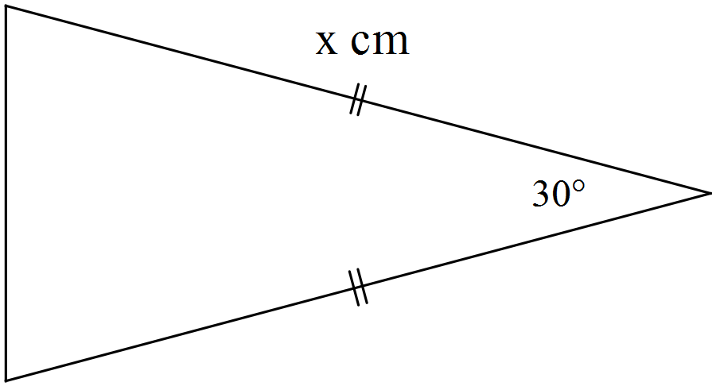

**Question 5 [4 marks]**

i) Find *x* in simplified exact form in the following diagram:

a)



1. b)

***x***

***x***

ii) Find θ in the following diagram.

$$6cm$$

$$60\sqrt{3}$$

$$120cm$$





**AEMAM Unit 1 – Test 1 – 2019**

**Name: Time allowed – 30 minutes**

**Calculator Assumed Section (1xA4 page of double sided notes and approved**

**calculators. Formula sheet provided.) – 28 marks**

**Question 6 [8 marks – 3, 2, 3]**

1. Show that the smallest angle in a 5 cm, 8 cm, 11 cm triangle is 24.6o.

1. Hence, or otherwise, determine the area of the triangle.

1. Use the **Sine Rule** to determine the size of the angle opposite the 8cm side.

**Question 7 [6 marks – 2, 2, 2]**

1. A 3.6 m long ladder first rests against a vertical wall *BC*, making an angle of 70° with the horizontal ground. The ladder is rotated in a vertical plane about *E* to rest against wall *AD*, reaching a point 2.6 m above the ground.

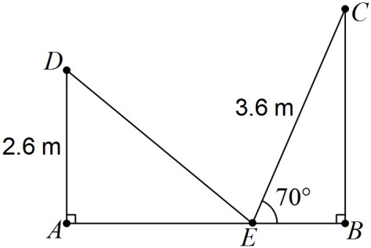

Showing use of trigonometry, determine

* + - 1. the angle through which the ladder was rotated.

* + - 1. the distance *AB*.

* + - 1. the distance *DC*.

**Question 8** **[6 marks]**

Determine, correct to 2 decimal places, the length of side BD in the diagram below.

Note: Diagram not drawn to scale.

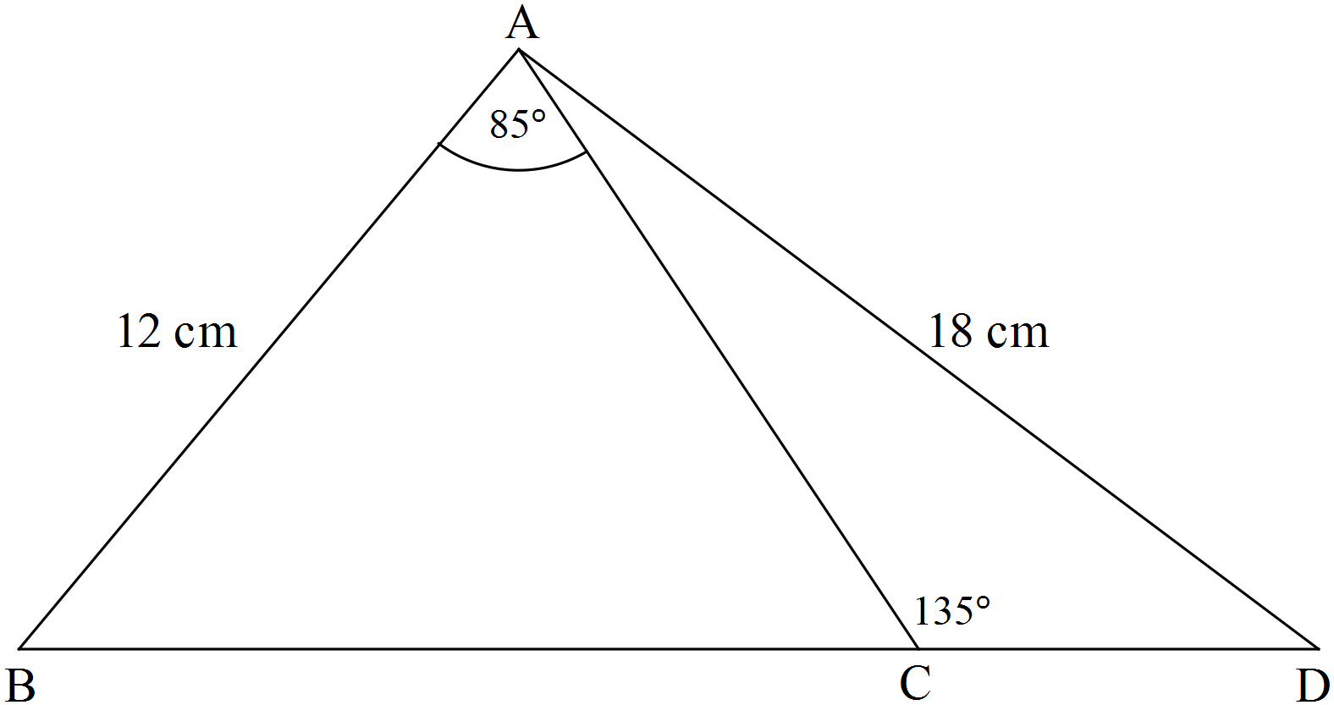

**Question 9 [8 marks]**

In triangle ABC, A = 30o, a = 5 and c = 7.

Find the difference in the two possible areas for ∆ABC.

*Hint: Draw a labelled diagram*

**END OF ASSESSMENT**